1. **Inflow** -  [Inventory Management Software System Made Easy | inFlow (inflowinventory.com)](https://www.inflowinventory.com/)

* cloud version
* Payment option Both Monthly and Yearly **[Offering 35% discount to help small business in india].**
* Best Plan – “**MID Size Rs 439 USD per Month (Rs 36,292.13)”** [ Consist of 10 users]

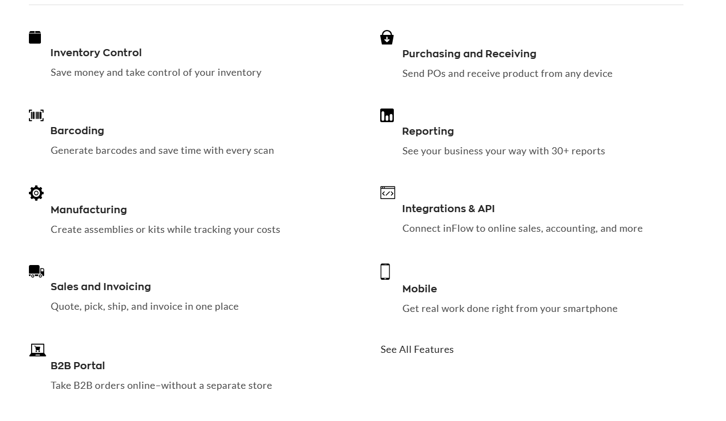

* **Plans and Pricing**

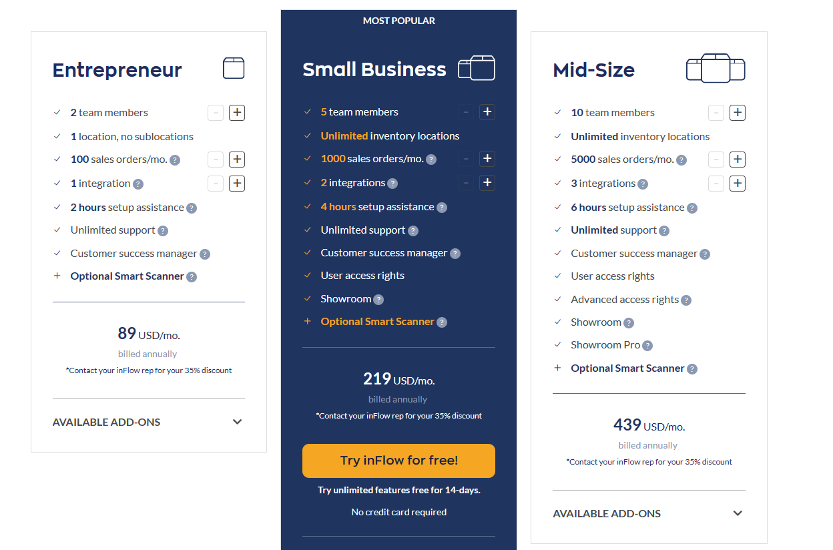

1. **Boxhero** - [Pricing | BoxHero (boxhero-app.com)](https://www.boxhero-app.com/en/pricing) **( Best Product)**

* cloud version
* Payment option Both Monthly and Yearly
* Best Plan – “**Business Plan $18 per Month (Rs 1488)**” [ Consist of 10 users]

**Features**

* [Inventory Control](https://www.boxhero-app.com/en/features/inventory)
* [Barcoding](https://www.boxhero-app.com/en/features/barcode)
* [Purchase & Sales](https://www.boxhero-app.com/en/features/sales)
* [Analytics & Reporting](https://www.boxhero-app.com/en/features/analytics)
* **Plans and Pricing**

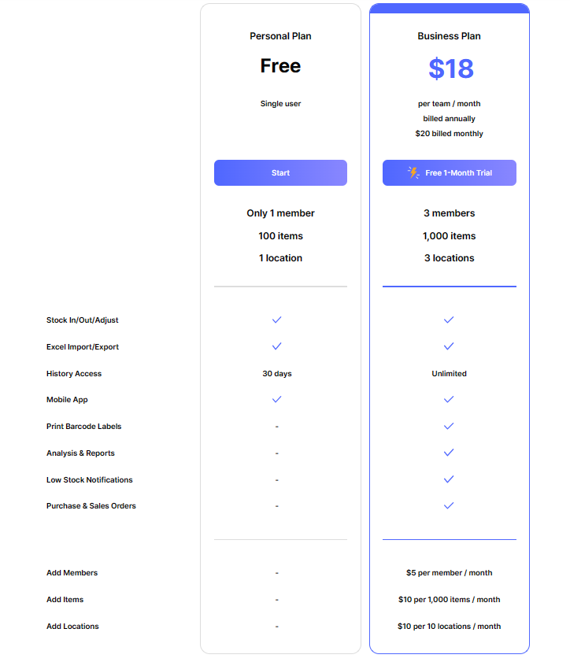

1. **Ordoro** - [Inventory Management | Ordoro](https://www.ordoro.com/features/inventory-management) **( Best Product))**

* cloud version
* Payment option Both Monthly
* Best Plan – “**Advanced Plan $59 per Month (Rs 4877.97)**” [ Consist of Unlimted users]

**Features**

* Automated low-stock alerts and reporting
* Supplier management
* Purchase orders and goods receipts
* Kitting and bundling
* Bill of materials and manufacturing orders
* Multi-warehouse management
* Set max export, percentages, and reserve quantities by sales channels
* Track lead times by suppliers
* FBA inventory sync, FBA/FBM item tracking, and Amazon Latency
* 3PL order management
* Open API for platform-agnostic integration
* Automatic inventory writeback
* Order routing and splitting
* Automatic order tagging
* Flash shipping and postage reporting
* Realtime P&L summaries
* Bulk inventory uploads
* Enjoy seamless onboarding
* Get up and running in minutes
* Spend less time training
* Never fill out support tickets
* Always talk to a real person (not an AI bot)
* **Plans and Pricing**

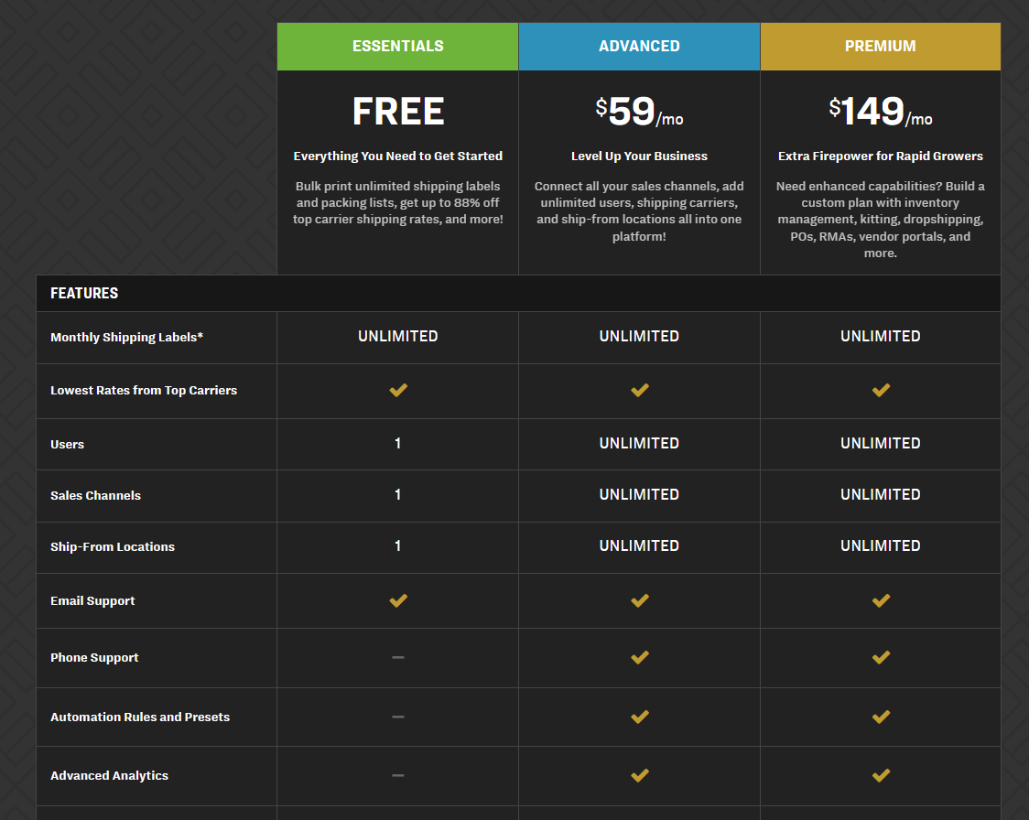

1. **Zoho Inventory** - [Inventory Management Software| Online Inventory Management – Zoho Inventory](https://www.zoho.com/in/inventory/?ireft=nhome&src=home1-dd)

* cloud version
* Payment option Both Monthly and Yearly
* Best Plan – “**Premium Plan Rs 40,999 per Year**” [ Consist of 10 users]

**Inventory Feature**

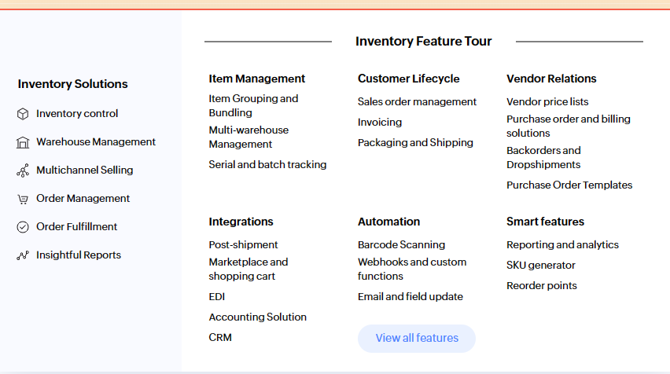

* **Plans and Pricing**

